


2024 MeTRIC Symposium Device Gallery
Created By: Gabriel Mongefranco, Mobile Data Architect University of Michigan - Eisenberg Family Depression Center

Examples of Mobile Technologies Used in Research
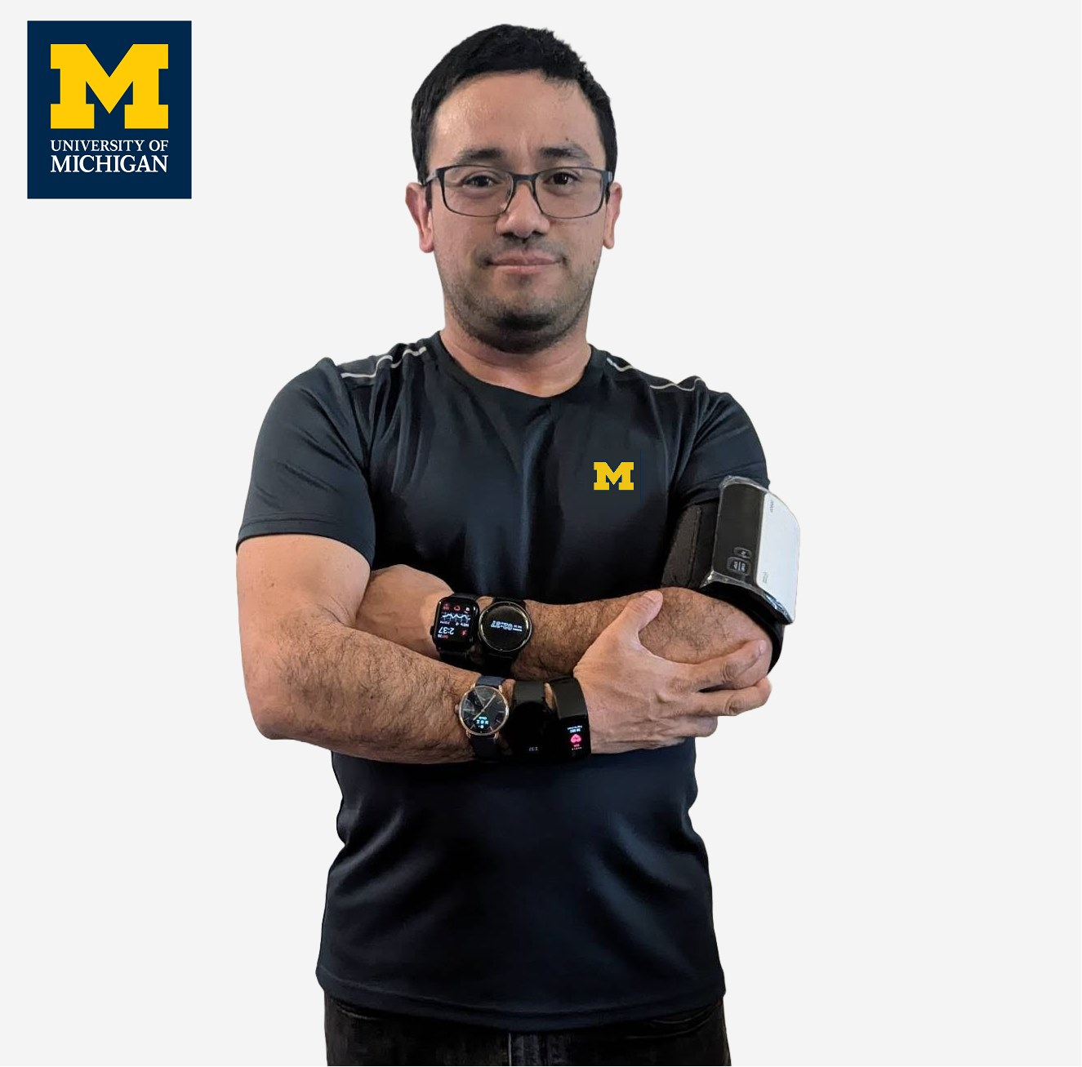
A small selection of wearable and nearable devices displayed at the 2024 University of Michigan's MeTRIC Symposium. View full article at: https://michmed.org/efdc-kb.
Click on each image caption to read the pros & cons of each device.
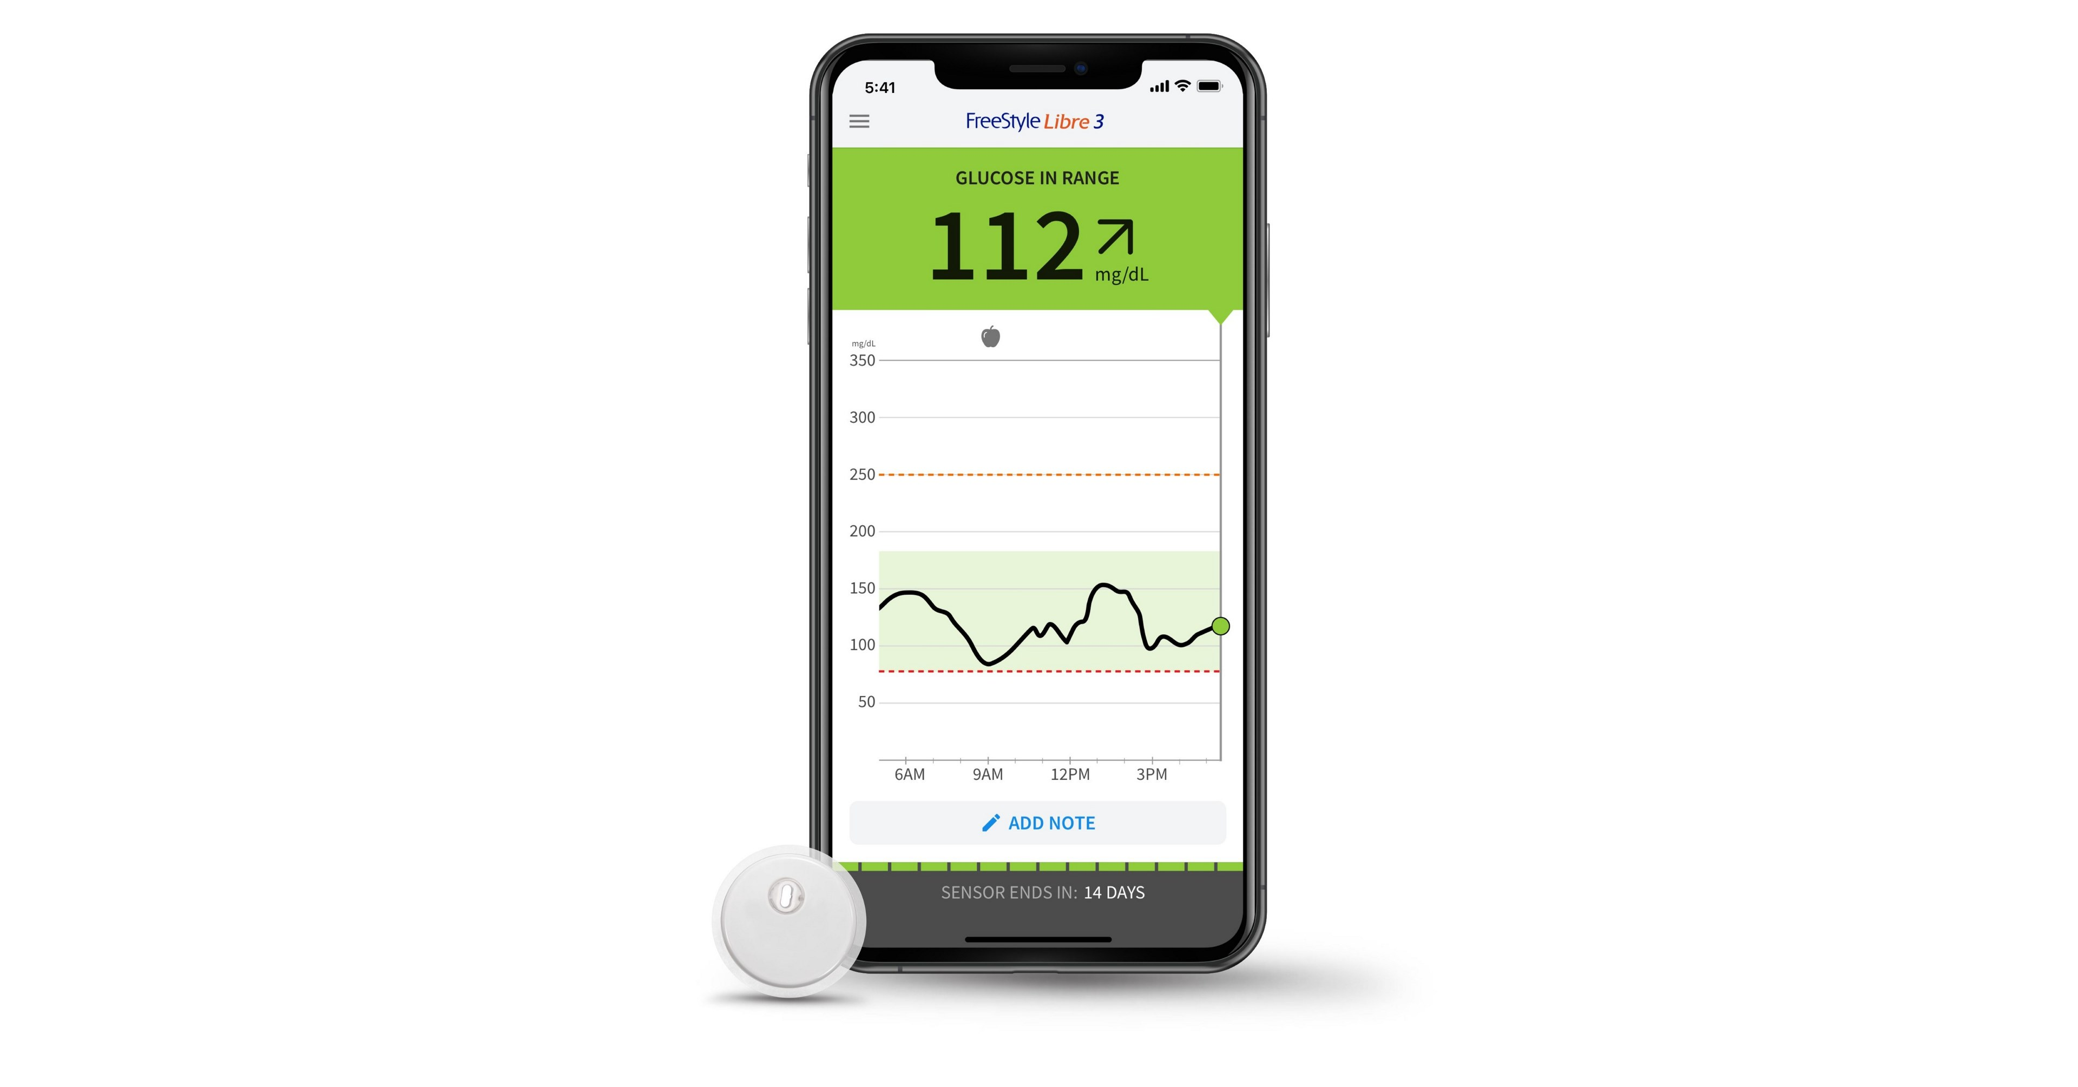
1 - Abbott Freestyle Libre 3 & 3 Plus
Main Features:
- 24/7 estimated blood glucose, 1-minute refreshes
- Worn on back of the arm
- Lasts 14-days (Libre 3) or 15 days (Libre 3 Plus)
- Can transmit data to smartphones (NFC and Bluetooth required) or optional receiver
Pros:
- Compatible with some insulin pumps loops (3 Plus)
- Very small sensor, painless insertion, comfortable
Cons:
- Insertion and setup can be difficult for those with limited dexterity
- Limited water resistance
- Virtually no integration with third parties despite API
Device provided by: Sam Chuisano (PM&R) (Libre 3), Gabriel Mongefranco (EFDC) (Libre 3 Plus)
Product webpage: https://www.freestyle.abbott/us-en/products/freestyle-libre-3.html
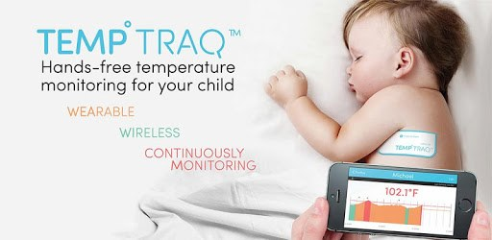
2 - Blue Spark TempTraq TT100 24hr
Main Features:
- Continuous axillary temperature (converted to oral equivalent) every 2 minutes, over the life of the patch
- Available in 24, 48 and 72 hour versions
Pros:
- Integration with EHR systems via HL7
- Data available for download via clinic web app
- Comfortable to wear (though a little big - about the size of a credit card)
Cons:
- Requires a prescription and a clinic; not available through typical commercial channels
- Silicon adhesive is comfortable but can sometimes slide off the body
- No integration with Google/Apple or other consumer-oriented health apps
- Although app is easy to use, sync over Bluetooth can be a little complicated
Device provided by: Michelle Rozwadowski (MM Pediatrics, Hematology/Oncology)
Product webpage: https://temptraq.healthcare/
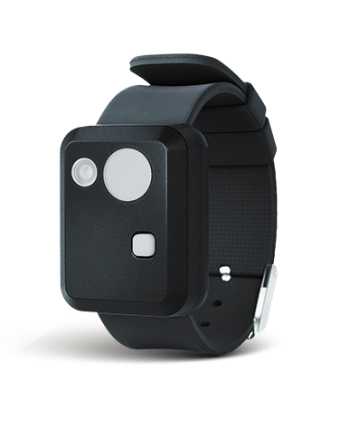
3 - Condor Instruments ActLumus Actigraph
Main Features:
- Actigraph with Melanopic and Photopic measurements (Melanopic EDI and Photopic Lux estimation)
- Can be worn on wrist for actigraphy, or chest for ambient light
- Activity, light, skin contact, and skin temperature sensors
Pros:
- Software is free
- Possible alternative to Fitbit for sleep tracking
Cons:
- Not available through typical commercial channels
- High cost for both hardware and per-device cloud service
- No integration with Google/Apple or other consumer-oriented health apps
Device provided by: Helen Burgess and Allie Rodgers (MM Psychiatry, Sleep & Circadian Lab)
Product webpage: https://condorinst.com/en/actlumus-actigraph/
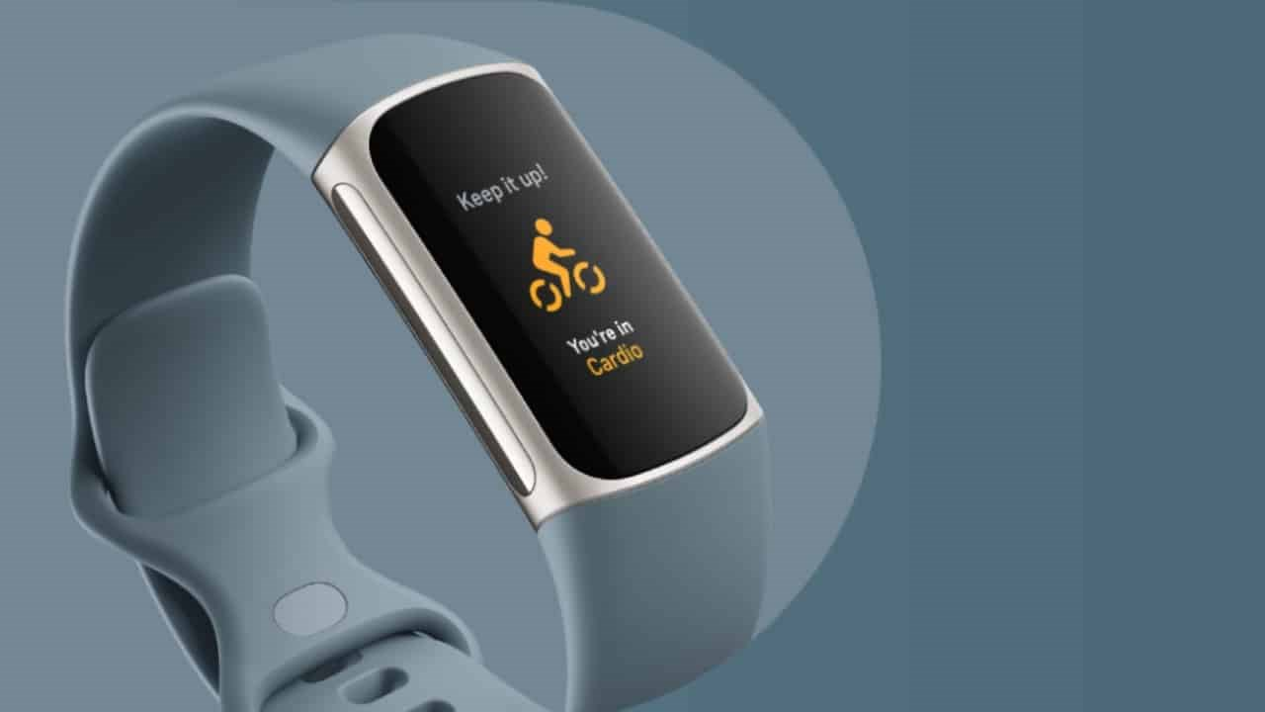
4 - Fitbit Charge 6
Main Features:
- Sleep tracking, stages
- Heart rate, SPO2, skin temperature (variation only), stress, ECG (phone app required)
- PPG, EDA, ambient light, altimeter, compass, GPS
Pros:
- Compatible with many study management systems, third-party apps, and Google Health Connect
- Lower price point than similar devices
- Easy to use
- Battery can last 3-7 days depending on 24/7 features turned on
Cons:
- Setup can be difficult
- Requires a personal Gmail account - does not work with Google Workspace / Google Apps accounts
- No integration with Apple Health
- Uncomfortable to wear; many participants have reported skin reactions
Device provided by: Eisenberg Family Depression Center
Product webpage: https://store.google.com/us/product/fitbit_charge_6
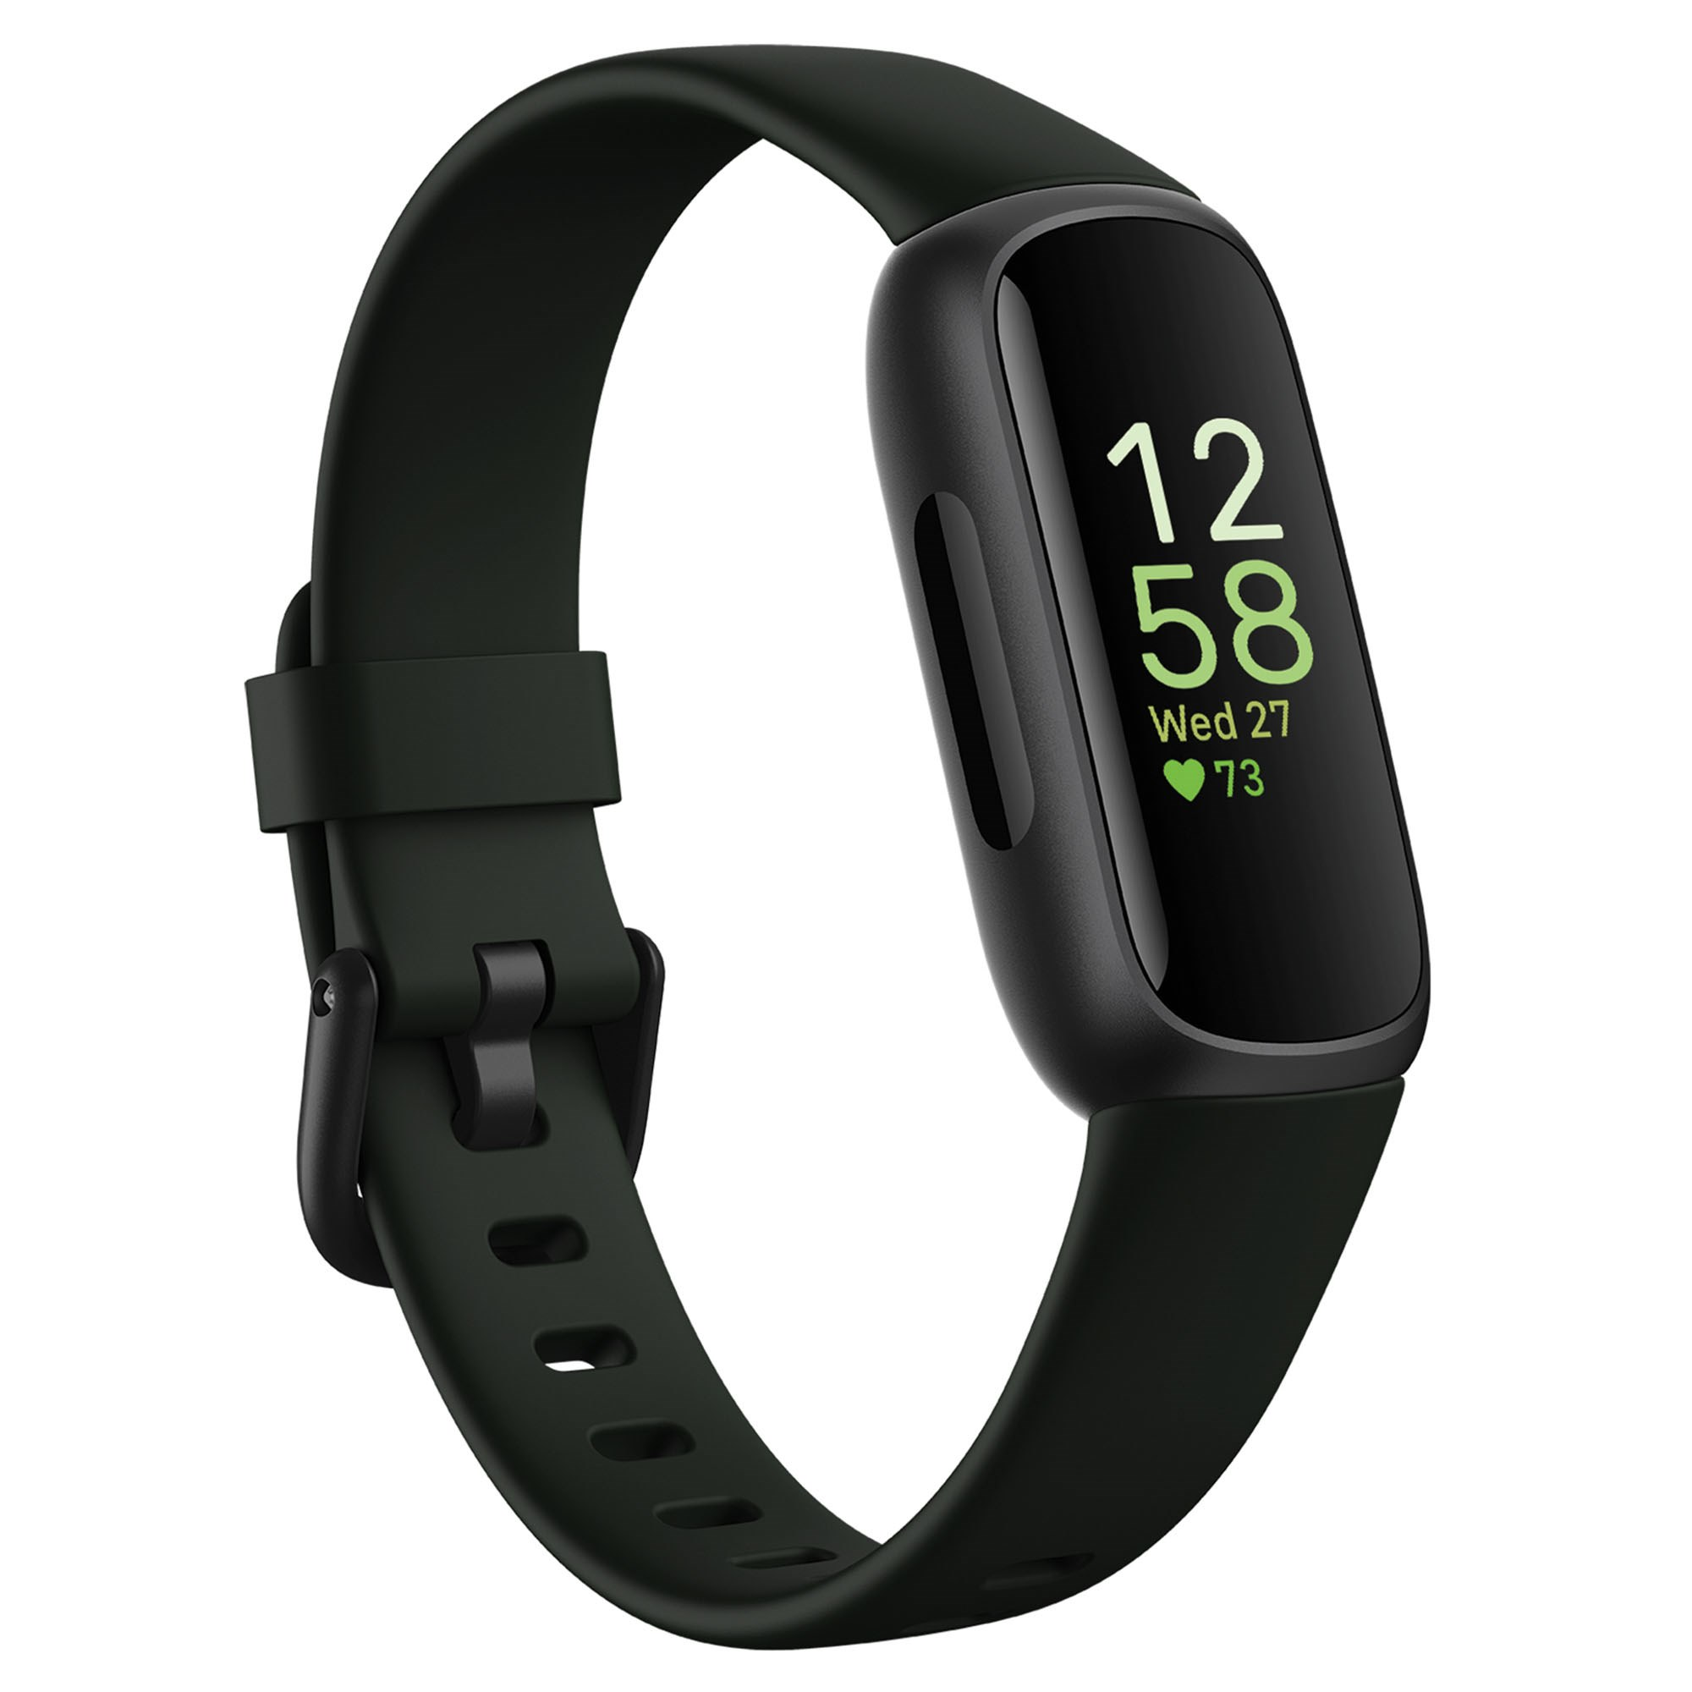
5 - Fitbit Inspire 3
Main Features:
- Sleep tracking, stages
- 24/7 heart rate, SPO2, skin temperature (variation only)
- PPG, ambient light
Pros:
- Compatible with many study management systems, third-party apps, and Google Health Connect
- One of the lowest price points for fitness trackers
- Easy to use. lightweight, and comfortable to wear
- Battery can last 3-10 days depending on features being used
Cons:
- Requires a personal Gmail account - does not work with Google Workspace / Google Apps accounts
- No integration with Apple Health
Device provided by: Reema Kadri (PM&R / MICHR)
Product webpage: https://store.google.com/us/product/fitbit_inspire_3
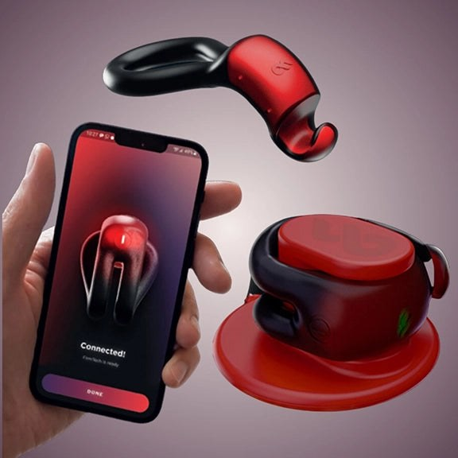
6 - FirmTech TechRing
Main Features:
- Measures nocturnal penile tumescence via two separate pressure sensors
- Can record erection detection, firmness and duration data during intercourse or overnight
Pros:
- Comfortable, easy to use, and adjustable
- App includes self-reporting features that are saved to the cloud along with sensor data
- Raw sensor data is available upon request
Cons:
- Users complain of difficulty pairing over Bluetooth
- Must be thoroughly cleaned and fully recharged daily
- No integration with third parties yet (however, being a first-in-class device means that data models are not yet available in consumer health apps)
Device provided by: Riley Daily (FirmTech Inc.)
Product webpage: https://myfirmtech.com/products/the-tech-ring
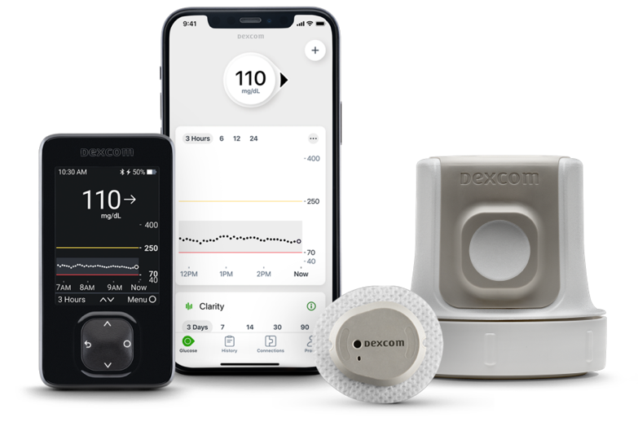
7 - Dexcom G7 Sensor & Reader
Main Features:
- 24/7 estimated blood glucose, 5-minute refreshes
- Worn on back of the arm (adults) or upper buttocks (children)
- Lasts 10-days (plus a 12-hour "grace period")
- Can transmit data to smartphones (Bluetooth required), Apple Watch, or optional receiver
Pros:
- Compatible with some insulin pumps loops
- Comfortable to wear
- Can be used during swimming
- Plenty of 3rd party integrations, including Google/Apple/Glooko/Tidepool
Cons:
- Insertion and over patch placement can be difficult for those with limited dexterity
- Requires permission to use in research studies (depending on industry partner)
- Insertion can be painful
Device provided by: Gabriel Mongefranco (EFDC)
Product webpage: https://www.dexcom.com/en-us/g7-cgm-system
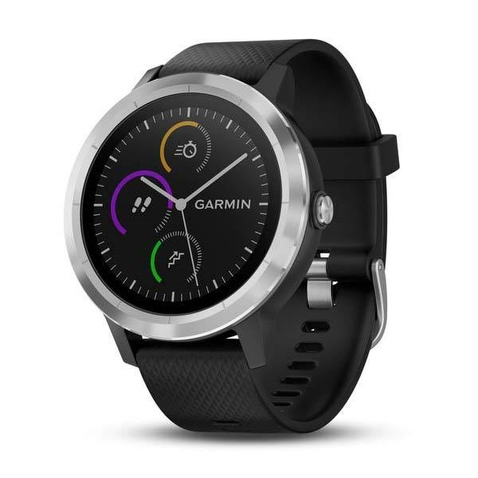
8 - Garmin Vivoactive 4 & 5
Main Features:
- Sleep tracking, stages, naps
- Heart rate, 24/7 SPO2, stress
- PPG, EDA, altimeter, compass, GPS, gyroscope
Pros:
- Raw sensor data available via SDK
- ATN+ for additional sensors and gym equipment
- Well-documented API plus integration with Google
- Long battery life (3-7 days)
- Can sync via Wi-Fi (on-demand), through app, or via included USB cable
Cons:
- Setup and use have low-medium difficulty
- Overwhelming amounts of data and options in the app
- Integration with Apple is read-only
Device provided by: Gabriel Mongefranco (4) and Eisenberg Family Depression Center (5)
Product webpage (4): https://www.garmin.com/en-US/p/643382
Product webpage (5): https://www.garmin.com/en-US/p/1057989
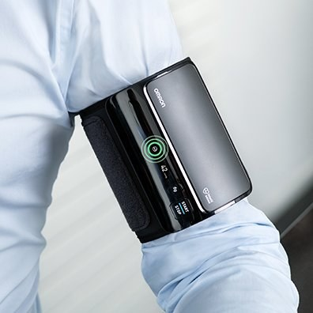
9 - Omron Evolv (Upper Arm)
Main Features:
- One-piece blood pressure monitor
- On-demand blood pressure readings, with option to schedule reminders
- Automatically syncs data when smartphone is in range (with app running in background)
Pros:
- Extremely easy to setup and use
- Batteries (AAA) can last several months
- Very lightweight and comfortable
- Spring-loaded cuff ensures correct fit with minimal adjustments
- Many third-party integrations including Google/Apple
Cons:
- Battery compartment can be difficult to open
Device provided by: Eisenberg Family Depression Center
Product webpage: https://omronhealthcare.com/products/evolv-wireless-upper-arm-blood-pressure-monitor-bp7000/
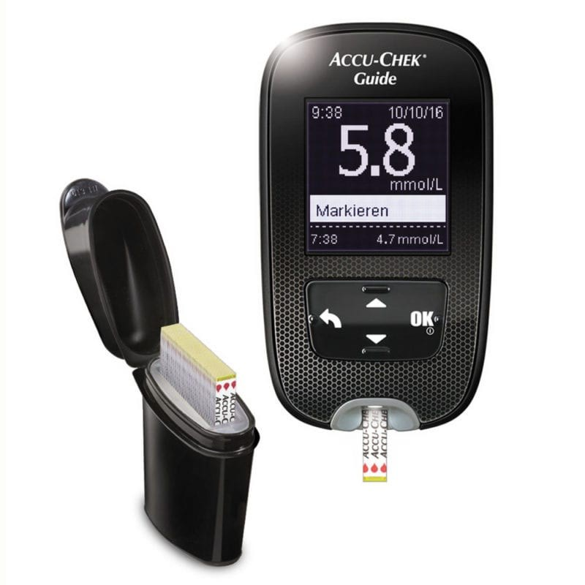
10 - Roche Accu-Check Guide & Guide Me
Main Features:
- Measures blood glucose and syncs to phone automatically over Bluetooth
- Available over-the-counter, and sometimes covered by prescription or medical (DME) health plans
Pros:
- Fast readings (<4 seconds) with minimal amount of blood needed
- Integrations with many clinical trial management systems, third-party health apps, and Google/Apple/Glooko/Tidepool
- Easy to use and to setup
- Long-lasting batteries (>3 months)
- Can store a large number of readings to be retrieved via USB if needed
Cons:
- Non-continuous glucose readings
Devices provided by: Gabriel Mongefranco (EFDC)
Product webpage (Accu-Chek Guide): https://www.accu-chek.com/products/meters/guide
Product webpage (Accu-Chek Guide Me): https://www.accu-chek.com/products/meters/guide-me
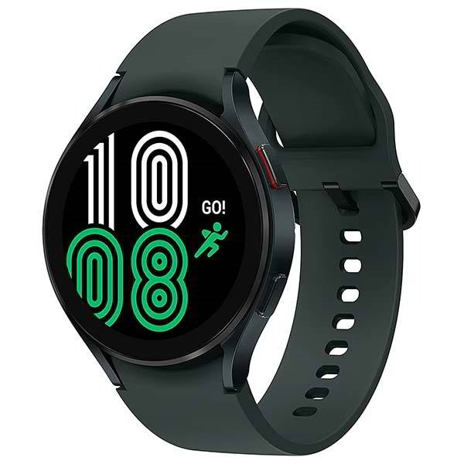
11 - Samsung Galaxy Watch6
Main Features:
- Sleep tracking, stages
- Heart rate (10 second intervals), SPO2, skin temperature, stress, body composition (via EDA)
- PPG, EDA, ambient light, speaker, mic, altimeter, compass, gyroscope
Pros:
- Access to raw sensor data via SDK
- Can be used while swimming
- Integration with Google
Cons:
- Setup can be difficult, and day-to-day use can be confusing due to WearOS permissions
- Very short battery life (14-28 hours)
- Requires Android, and works best with Galaxy Phone
Device provided by: Eisenberg Family Depression Center
Product webpage: https://www.samsung.com/us/watches/galaxy-watch6
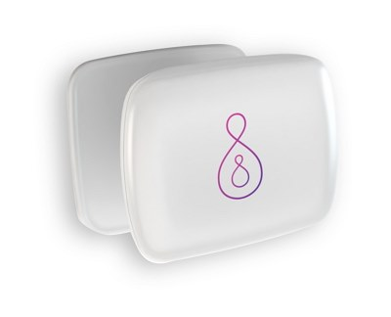
12 - Smart Human Dynamics Pregnancy Coach
Main Features:
- Sleep tracking, stages, heart rate, body position during sleep
- Raw position sensor data available in standard export
- Vibration alerts to prevent supine sleep during pregnancy
- Can be worn with clip-on or adhesive patch
Pros:
- Raw sensor data available
- Easy to use and comfortable to wear
- Long battery life (5 days)
Cons:
- Only 30 adhesive patches included
- No third-party integrations yet
Device provided by: Louise O'Brien (Neurology / Obstetrics & Gynecology)
Product webpage: https://www.pregnancycoach.com/pregnancy-coach/
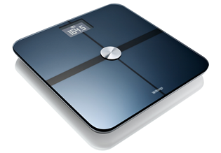
13 - Withings Body Comp
Main Features:
- Tracks body weight, fat mass, water mass, bone mass, muscle mass, visceral fat, and heart rate
- EDA, pulse wave velocity, HR
Pros:
- Easy to use and setup
- Long battery life (12-18 months)
- Many third-party integrations, including Google/Apple
- Syncs automatically via Wi-Fi
Cons:
- Setup requires smartphone and Wi-Fi password
Device provided by: Gabriel Mongefranco (EFDC)
Product webpage: https://www.withings.com/us/en/body-comp
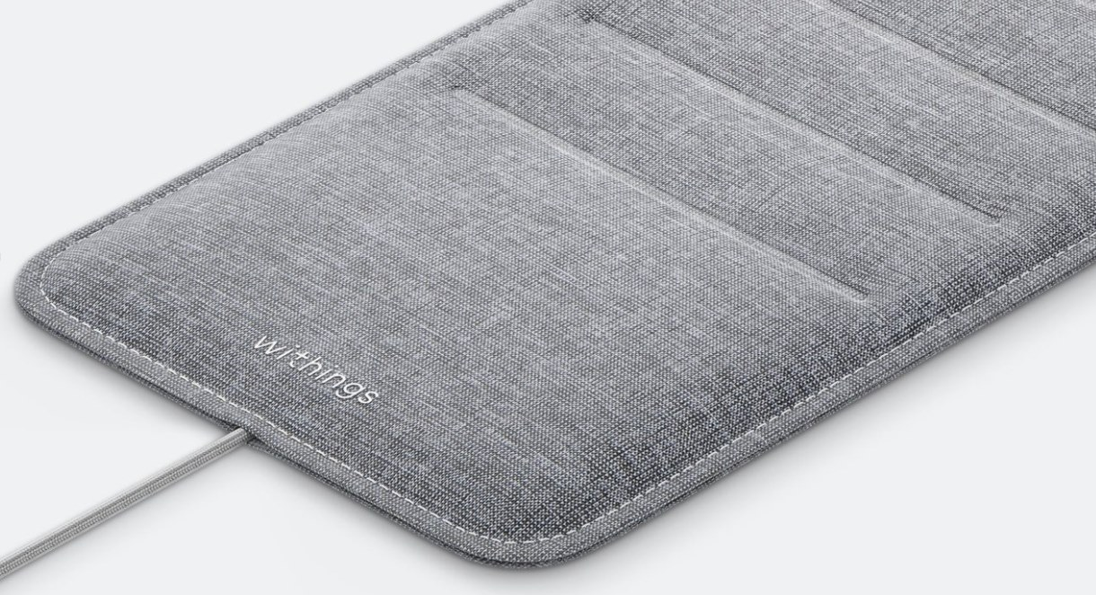
14 - Withings SLEEP
Main Features:
- Sleep tracking, stages
- Heart rate, snoring detection
- Mat is placed under a standard mattress and plugged into included USB charger
Pros:
- Syncs automatically via Wi-Fi
- Easy to use
- Clinical-grade reports for providers
- Many third-party integrations, including Google/Apple
Cons:
- Setup requires a smartphone, Wi-Fi password, and 10-minute calibration
Device provided by: Eisenberg Family Depression Center
Product webpage: https://www.withings.com/us/en/sleep
Learn more at: https://michmed.org/W4G3N

Disclaimer:
The Eisenberg Family Depression Center does not recommend any specific brands or devices. The information in this article is purely for informational purposes only. Product images are covered under Creative Commons license and belong to their respective owners.

© 2023 Regents of the University of Michigan
Permission is granted to copy, distribute and/or modify this document under the terms of the GNU Free Documentation License, Version 1.3 or any later version published by the Free Software Foundation with no Invariant Sections, no Front-Cover Texts, and no Back-Cover Texts. A copy of the license is included in the section entitled "GNU Free Documentation License".

